1. **(Y 2)**

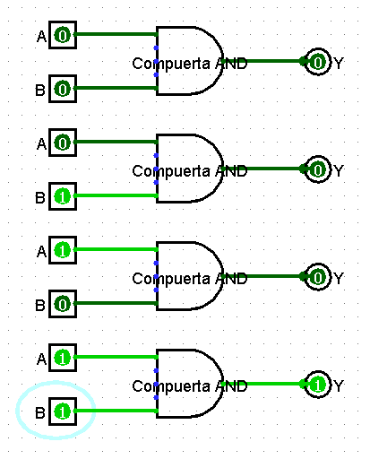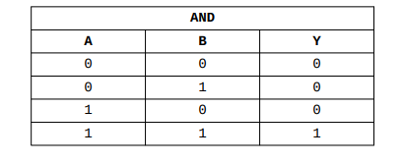

1. Al colocar la “X” azul como valor de entrada posible como uno de los 3 estados para el pin, se indica que el pin tiene el estado de alta impedancia (High-Z). Esto implica que el pin puede estar “flotante” o desconectado. Cuando hacemos esto, pueden pasar 2 cosas con la salida dependiendo del otro pin que tengamos. Si le otra entrada es un 0, no afectará en nada al circuito ya que ambos están de cierta forma inactivos.

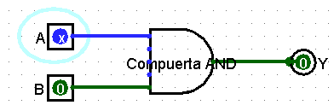

Por otro lado, si el segundo pin trae un valor de 1, la salida se mostrará con error debido a la incoherencia de datos, es decir, encuentra un valor indeterminado.

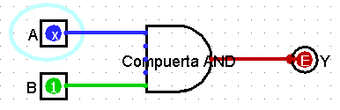

2. $f(A,B,C) = (/A * /B * C) + (/A * /B * /C) + (A * /B * C)$:

|  |  |  |  |  |  |  |  |  |  |
| --- | --- | --- | --- | --- | --- | --- | --- | --- | --- |
| A | B | C | /A | /B | /C | /A*/B*C | /A*/B*/C | A*/B*C | (/A * /B * C) + (/A * /B * /C) + (A * /B * C) |
| 0 | 0 | 0 | 1 | 1 | 1 | 0 | 1 | 0 | 1 |
| 0 | 0 | 1 | 1 | 1 | 0 | 1 | 0 | 0 | 1 |
| 0 | 1 | 0 | 1 | 0 | 1 | 0 | 0 | 0 | 0 |
| 0 | 1 | 1 | 1 | 0 | 0 | 0 | 0 | 0 | 0 |
| 1 | 0 | 0 | 0 | 1 | 1 | 0 | 0 | 0 | 0 |
| 1 | 0 | 1 | 0 | 1 | 0 | 0 | 0 | 1 | 1 |
| 1 | 1 | 0 | 0 | 0 | 1 | 0 | 0 | 0 | 0 |
| 1 | 1 | 1 | 0 | 0 | 0 | 0 | 0 | 0 | 0 |

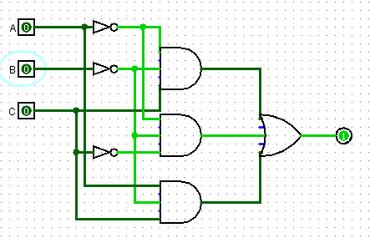

$f(A,B,C) = (/A * B * /C) + (/A ∙ /B * C) + (A * B * C) + (A * /B * C) + (A * B * /C)$

|  |  |  |  |  |  |  |  |  |  |  |  |
| --- | --- | --- | --- | --- | --- | --- | --- | --- | --- | --- | --- |
| A | B | C | /A | /B | /C | /A*B*/C | /A*/B*C | A*B*C | A*/B*C | A*B*/C | (/A * B * /C) + (/A ∙ /B * C) + (A * B * C) + (A * /B * C) + (A * B * /C) |
| 0 | 0 | 0 | 1 | 1 | 1 | 0 | 0 | 0 | 0 | 0 | 0 |
| 0 | 0 | 1 | 1 | 1 | 0 | 0 | 1 | 0 | 0 | 0 | 1 |
| 0 | 1 | 0 | 1 | 0 | 1 | 1 | 0 | 0 | 0 | 0 | 1 |
| 0 | 1 | 1 | 1 | 0 | 0 | 0 | 0 | 0 | 0 | 0 | 0 |
| 1 | 0 | 0 | 0 | 1 | 1 | 0 | 0 | 0 | 0 | 0 | 0 |
| 1 | 0 | 1 | 0 | 1 | 0 | 0 | 0 | 0 | 1 | 0 | 1 |
| 1 | 1 | 0 | 0 | 0 | 1 | 0 | 0 | 0 | 0 | 1 | 1 |
| 1 | 1 | 1 | 0 | 0 | 0 | 0 | 0 | 1 | 0 | 0 | 1 |

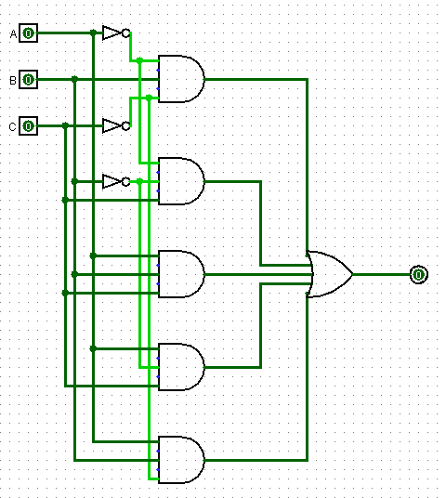

$f(A,B,C) = (A* /B* /C) + (/A * B * /C) + (/A * /B * C) + (A * B * C)$

|  |  |  |  |  |  |  |  |  |  |  |
| --- | --- | --- | --- | --- | --- | --- | --- | --- | --- | --- |
| A | B | C | /A | /B | /C | A*/B*/C | /A*B*/C | /A*/B*C | A*B*C | (A* /B* /C) + (/A * B * /C) + (/A * /B * C) + (A * B * C) |
| 0 | 0 | 0 | 1 | 1 | 1 | 0 | 0 | 0 | 0 | 0 |
| 0 | 0 | 1 | 1 | 1 | 0 | 0 | 0 | 1 | 0 | 1 |
| 0 | 1 | 0 | 1 | 0 | 1 | 0 | 1 | 0 | 0 | 1 |
| 0 | 1 | 1 | 1 | 0 | 0 | 0 | 0 | 0 | 0 | 0 |
| 1 | 0 | 0 | 0 | 1 | 1 | 1 | 0 | 0 | 0 | 1 |
| 1 | 0 | 1 | 0 | 1 | 0 | 0 | 0 | 0 | 0 | 0 |
| 1 | 1 | 0 | 0 | 0 | 1 | 0 | 0 | 0 | 0 | 0 |
| 1 | 1 | 1 | 0 | 0 | 0 | 0 | 0 | 0 | 1 | 1 |

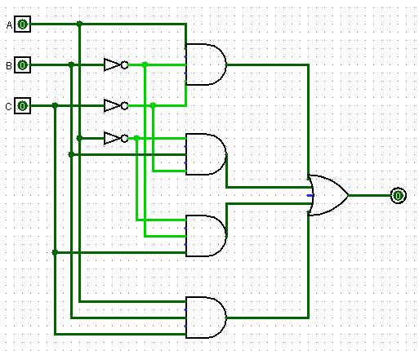

$f(A,B,C,D) = (/A*B*/C*D) + (A*/B*C*/D) + (/A*/B*/C*/D)$

|  |  |  |  |  |  |  |  |  |  |  |  |
| --- | --- | --- | --- | --- | --- | --- | --- | --- | --- | --- | --- |
| A | B | C | D | /A | /B | /C | /D | /A*B*/C*D | A*/B*C*/D | /A*/B*/C*/D | (/A*B*/C*D) + (A*/B*C*/D) + (/A*/B*/C*/D) |
| 0 | 0 | 0 | 0 | 1 | 1 | 1 | 1 | 0 | 0 | 1 | 1 |
| 0 | 0 | 1 | 0 | 1 | 1 | 0 | 1 | 0 | 0 | 0 | 0 |
| 0 | 1 | 0 | 0 | 1 | 0 | 1 | 1 | 0 | 0 | 0 | 0 |
| 0 | 1 | 1 | 0 | 1 | 0 | 0 | 1 | 0 | 0 | 0 | 0 |
| 1 | 0 | 0 | 0 | 0 | 1 | 1 | 1 | 0 | 0 | 0 | 0 |
| 1 | 0 | 1 | 0 | 0 | 1 | 0 | 1 | 0 | 1 | 0 | 1 |
| 1 | 1 | 0 | 0 | 0 | 0 | 1 | 1 | 0 | 0 | 0 | 0 |
| 1 | 1 | 1 | 0 | 0 | 0 | 0 | 1 | 0 | 0 | 0 | 0 |
| 0 | 0 | 0 | 1 | 1 | 1 | 1 | 0 | 0 | 0 | 0 | 0 |
| 0 | 0 | 1 | 1 | 1 | 1 | 0 | 0 | 0 | 0 | 0 | 0 |
| 0 | 1 | 0 | 1 | 1 | 0 | 1 | 0 | 1 | 0 | 0 | 1 |
| 0 | 1 | 1 | 1 | 1 | 0 | 0 | 0 | 0 | 0 | 0 | 0 |
| 1 | 0 | 0 | 1 | 0 | 1 | 1 | 0 | 0 | 0 | 0 | 0 |
| 1 | 0 | 1 | 1 | 0 | 1 | 0 | 0 | 0 | 0 | 0 | 0 |
| 1 | 1 | 0 | 1 | 0 | 0 | 1 | 0 | 0 | 0 | 0 | 0 |
| 1 | 1 | 1 | 1 | 0 | 0 | 0 | 0 | 0 | 0 | 0 | 0 |

